**ARDUINO BASED ANTI SLEEP ALARM FOR DRIVERS AND ACCIDENT PREVENTION USING IR SENSOR**

# ABSTRACT

This paper aims to create a framework to keep the car safe and secure through critical activity. When we run in ignorance we cannot take care of our own. If we make all vehicles with an automatic safety system that gives the driver a high level of protection, an alarm will also be issued. The device has an installed a IR sensor (For better performance use eye blink sensor). Once the driver has started the engine, the sensors automatically detect the blink of eye. On this device the output of the sensor is provided for comparison with ARDUINO. When the value reaches the set level, the buzzer automatically vibrates and the car stops automatically when IR sensor receives a signal from the transmission module.

**Keywords:** Arduino, IR Sensor, Buzzer, Dc Motor.

# INTRODUCTION

The failure of drivers in any vehicle incidents is a very important part of the dangerous problem facing the community . It can cause serious accidents for a variety of reasons and sometimes fatal as most drivers are out of control. Various things involved in car crashes such as high speed, sleep while driving other distractions such as texting while driving, talking to others, playing with children, etc. Citizens are aware of dangerous drive cars but do not understand the level of driving fatigue . About 64 people die everyday by road accident (Report 2020 by BJKS) and approximately 25000 lives are lost by every year. The Government of Bangladesh is planning to reduce the number of road accidents and fatalities. Globally, car accidents have proven to be one of the world's biggest security concerns. In 2023 about 5495 road accidents occurred in Bangladesh and 5024 people were killed and 7495 injured. A tired driver is not able to steer the car by those who are sleep at work, he is unable to take adequate steps leading to an accident so it is necessary to monitor the driver's drowsiness to avoid accidents. We focused on this issue using the eye twitch sensor to introduce a car accident prevention program. This paper examines the detection of various collisions and the reduction of such a system.

# SYSTEM DESCRIPTION

Embedded system devices are an important part of daily life. These are a combination of hardware and software, in which software is commonly known as hardware embedded software. One of the most important features of these systems is that they provide o/p within time limits. So we often use embedded systems on simple and sophisticated devices as well. In many devices like microwave, calculators, TV remote control, home security and crowded control systems, embedded system applications are very much involved in our real life. Embedded system block diagram is shown in Fig 1. Embedded devices are widely divided into several categories, depending on the hardware and software and the microcontroller "8 or 16 or 32-bit"

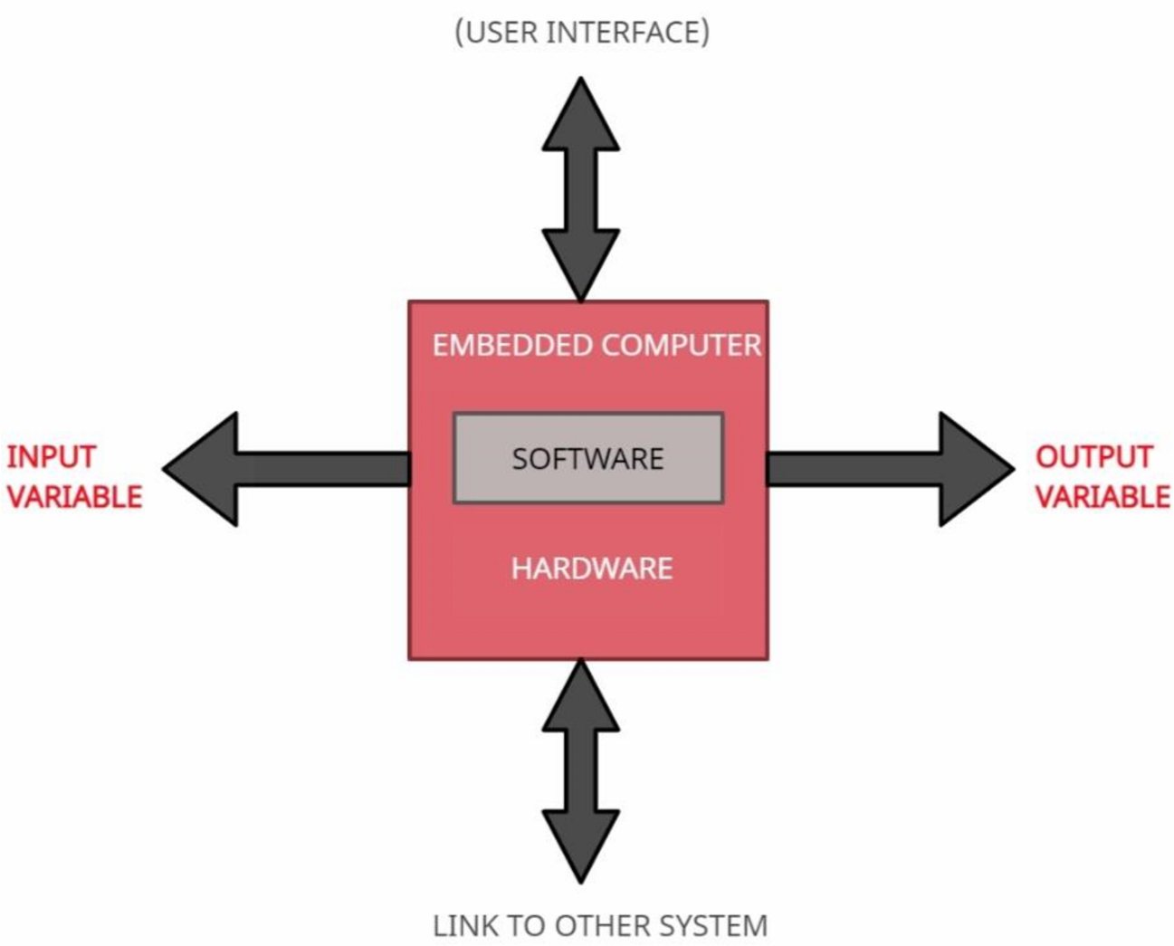

**Figure 1:** Embedded Systems block diagram

Airbags are currently a variety of features found in cars that are useful for car safety and security. In particular, these vehicles have been standard front airbags since 1998. This function aims that when the driver is sleepy, a buzzer signal in the system is provided, which reduces the driver's speed. The marketable design will still shut off the car power to maximize the chances of avoiding road accidents and opening the window for preventive and mitigation measures.

# SYSTEM DESIGN IMPLEMENTATION

System block diagram is comprise of: Eye blink (IR): related to sleep detection and alert the driver with the components used in the proposed operation are Eye blink length and frequency, Power supply, Buzzer, ARDUINO (Nano), Relay Module, DC as shown in Figure 2. The main component is Arduino Nano which is an ATmega328bootloader based microcontroller (MC) that performs all functions related to controlling the embedded system circuit. The blinking module works by illuminating the eye area with infrared light, and then detecting changes in scattered light using an image transistor and a separation circuit. Each of the components is described below.

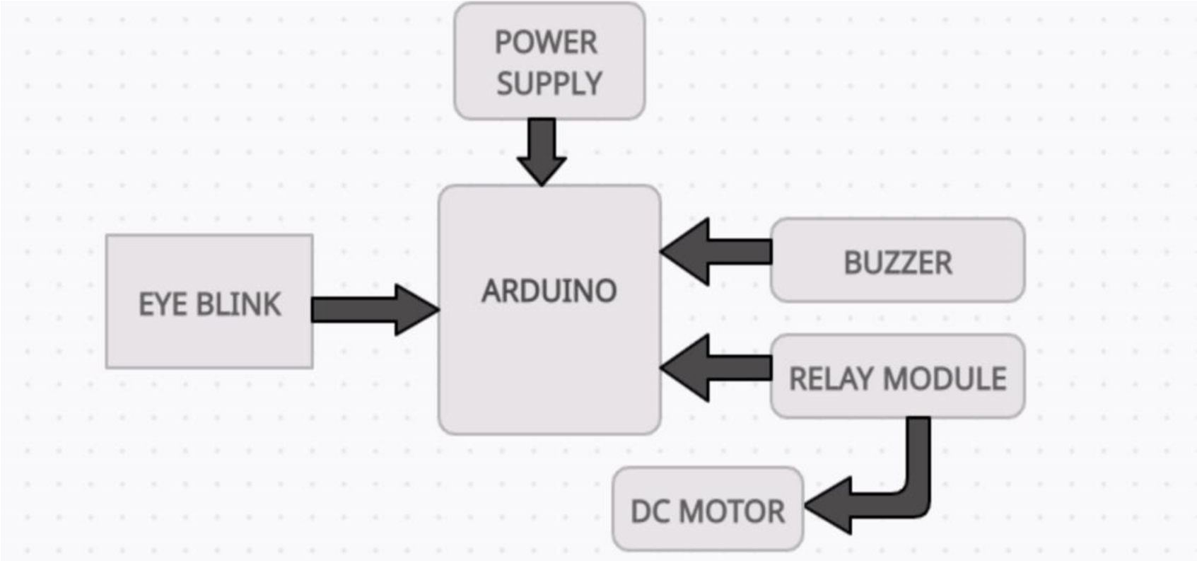

**Figure 2:** Schematic Block Diagram

1. **Arduino**

Arduino is an open source MC board based on ATmega328Pbootloader MC and developed by Arduino.cc. The board has 14 PINs and 6 analog pins. All of this will help the microcontroller by attaching the board to a computer for continuous operation. Strom supply of this board can be made using AC to DC Converter, USB cable, otherwise plug.Figure 3 shows arduino.

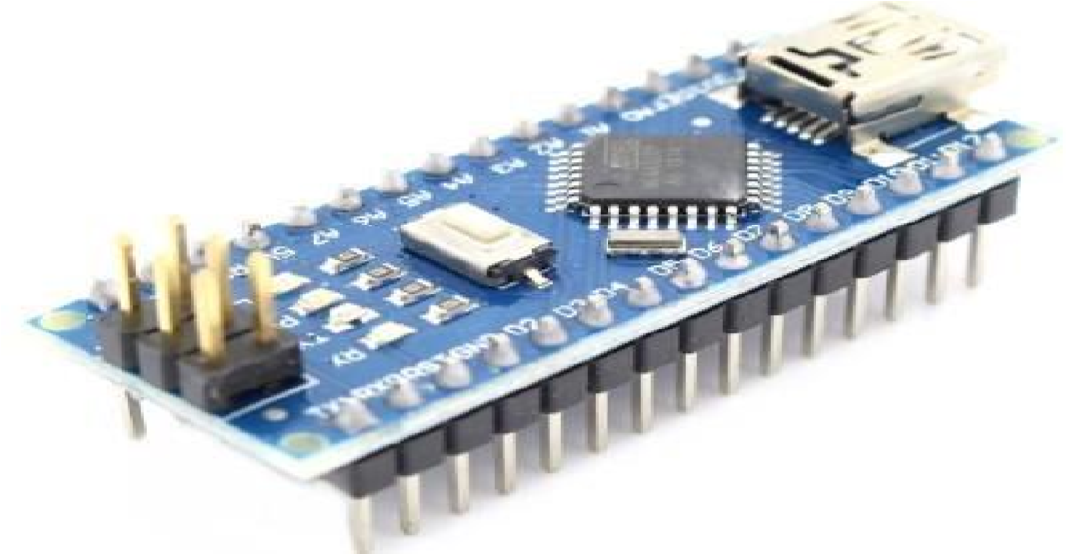

**Figure 3:** Arduino

1. **IR Sensor**

Using a phototransistor and a separator circuit, the blink sensor illuminates the eye area and eyelid with infrared light and detects changes in the reflected light. This study includes measuring and monitoring the blink of an eye with the help of an IR sensor. Closed eye indicates that the output of the IR receiver is high except that the output from the IR receiver is low. Figure 4 shows an instant blink sensor with an IR attached to it.

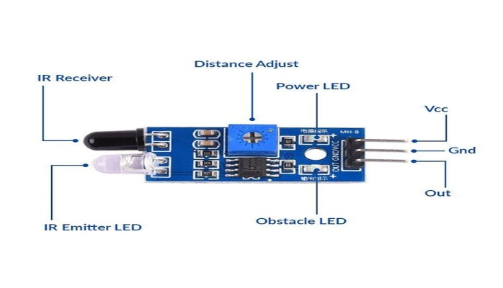

**Figure 4:** IR Sensor

1. **Buzzer**

The "Piezoelectric Sound Modules" presented here work on the concept of conversion using natural piezoelectric ceramic oscillation. These buzzers are available in lightweight, portable sizes ranging from a small diameter of 12 mm to large electrical outlets from peizo. The one shown in fig 6 below is a simple word that when enabled makes a continuous beep. To alert the driver when he first falls sleepy, the buzzer will be connected to the Eye-Blink Sensor.

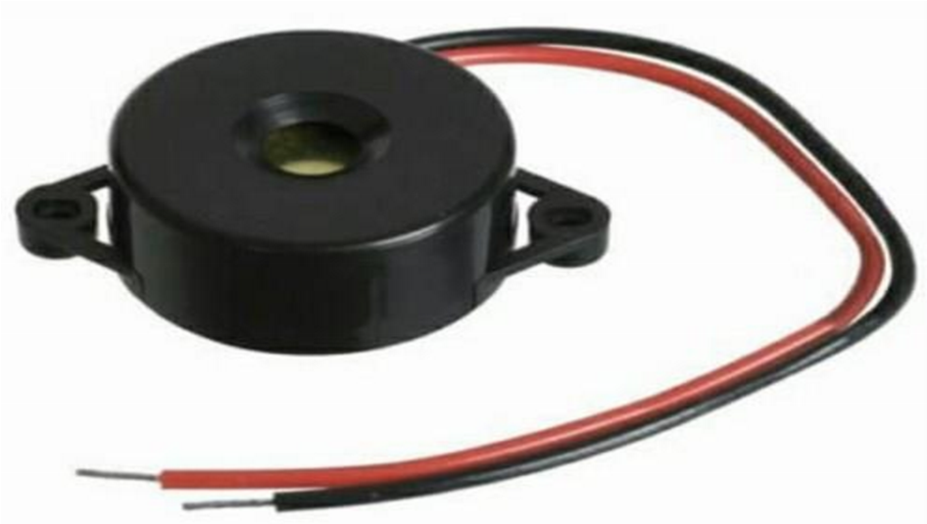

**Figure 5:** Buzzer

1. **DC Motor**

A DC is an electric motor that converts mechanical energy into electrical energy. The first widely used car was the DC engine, as it could be used for current direct distribution systems. The speed of a DC car can be adjusted to a wider spectrum, using a variable voltage and converting winding current strength into its field. Small DC engines are used in cars, toys and electrical appliances. The universal motor is capable of running precise action, and with integrated power tools and devices, a lightweight brush engine. Large DC engines commonly used in electric vehicles, elevator and hoist propulsion, as well as rolling steel drivers. For practical reasons in this project we have used a DC motor instead of a car. The motor acts as a car axle, and rotates as electricity is fed to it. Arduino NANO is an open source MC board based on ATmega328Pbootloader MC and developed by Arduino.cc. The merging process involves pre-processing the arduino system to convert the design into a C++ system. It will then be sent to a moderator who provides readable human code into computer-readable commands. Start the integration and upload process by pressing the sub-project toolbar or in the "Arduino IDE > Create & Upload menu.

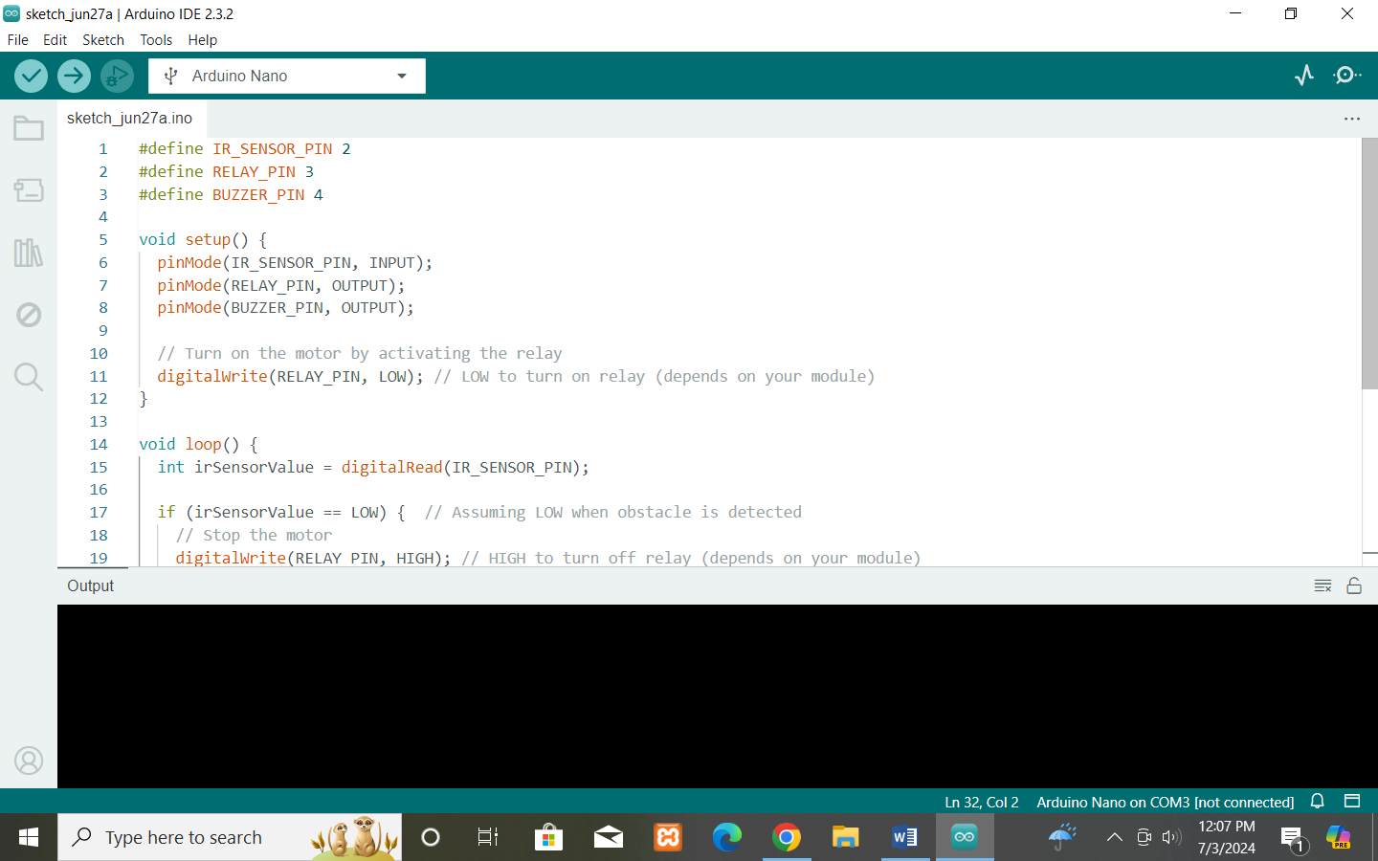

**Figure 6:** Arduino Compiler CODE:

**CODE:**

#define IR_SENSOR_PIN 2

#define RELAY_PIN 3

#define BUZZER_PIN 4

void setup() {

pinMode(IR_SENSOR_PIN, INPUT);

pinMode(RELAY_PIN, OUTPUT);

pinMode(BUZZER_PIN, OUTPUT);

// Turn on the motor by activating the relay

digitalWrite(RELAY_PIN, LOW); // LOW to turn on relay (depends on your module)

}

void loop() {

int irSensorValue = digitalRead(IR_SENSOR_PIN);

if (irSensorValue == LOW) { // Assuming LOW when obstacle is detected

// Stop the motor

digitalWrite(RELAY_PIN, HIGH); // HIGH to turn off relay (depends on your module)

// Activate the buzzer

digitalWrite(BUZZER_PIN, HIGH);

} else {

// Run the motor

digitalWrite(RELAY_PIN, LOW); // LOW to turn on relay

// Deactivate the buzzer

digitalWrite(BUZZER_PIN, LOW);

}

delay(100); // Delay for debouncing

}

# DESIGN ANALYSIS & RESULT

The system works with the goal of the eye twitch sensor that receives the driver's sleep. This effect is given to the buzzer. The rotation speed is reduced when the driver is sleep, while on the other hand the blink sensor receives the sensor stops the wheel. This program offers a new way to stop drowsy men. The device has an installed blink sensor. Once the driver has started the engine, the sensors automatically detect the blink of an eye . The process is depicted by the flow diagram shown in fig 7. On this device the sensor output is given to compare with ARDUINO. If the value exceeds the limit when the buzzer automatically generates vibration and the car stops automatically.

**Procedural steps for implementation:**

* Connect IR sensor to Arduino pin D2 illustrated in fig 8.
* Connect Buzzer to Arduino pin D4.

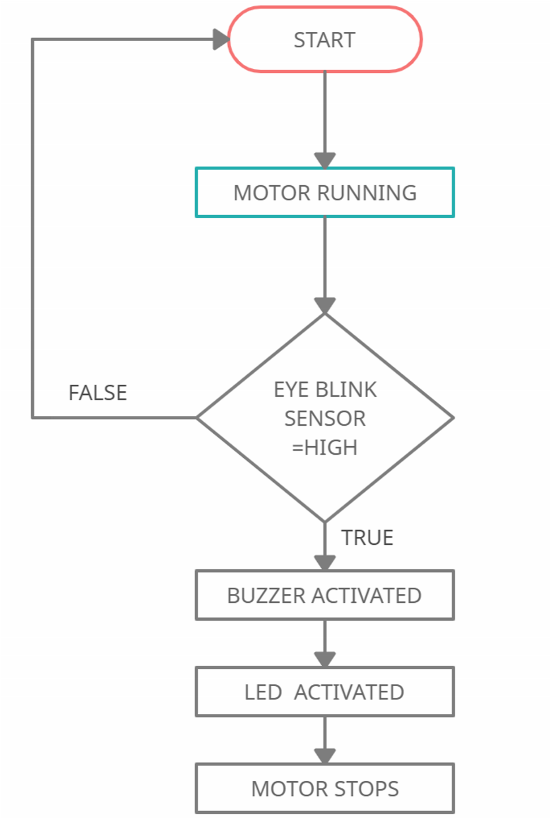

**Figure 7:** Flow Diagram **Methodical Steps for execution:**

Connect DC motor to relay and give relay connection to the Arduino pin D3. Now dump the code into Arduino using USB cable Connect USB cable to pc and open arduino software, enter the code and compile & run then select the arduino port and click upload button then your code will be uploaded into arduino. Now connect the batteries and check the output of IR sensor. If blink of eye is more than 2 seconds car (motor) will be stopped. The proposed work is completely illustrated in fig.8

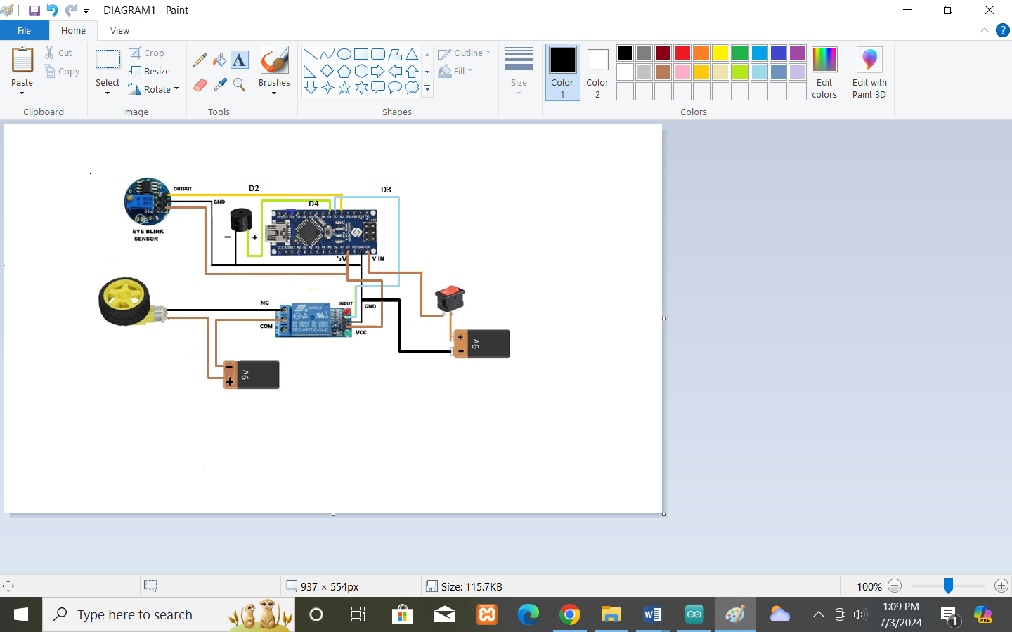

**Figure 8:** Final Connection of the Block

# CONCLUSION

People are increasingly exposed to dangers today. Therefore, we need to take action against this as an engineer and have the solution we need. Any automation is designed to protect a person. Such a model is tasked with developing a system for diagnosing and controlling the speed of vehicles to prevent accidents. To some extent, modern technology offers some hope of stopping these. This paper includes monitoring the blink of an eye with the help of an IR sensor. On this device the output of the sensor is provided for comparison with ARDUINO. When the value reaches the set level, the buzzer automatically vibrates , and the car stops automatically when the eye blink sensor receives a signal from the transmission component.

# REFERENCES

1. C.Prabha, R.Sunitha, R.Anitha “Automatic Vehicle Accident Detection and Messaging System Using GSM and GPS Modem”, IJAREEIE, Vol. 3, Issue 7, pp: 10723 – 10727, July 2014.
2. S. Gupta, K. Sharma, N. Salvekar and A. Gajra, "Implementation of Alcohol and Collision Sensors in a Smart Helmet," 2019 International Conference on Nascent Technologies in Engineering (ICNTE), Navi Mumbai, India, 2019, pp. 1-5, doi: 10.1109/ ICNTE44896.2019. 8945979.
3. Vardhini, P. A. H., Ravinder, M., Reddy, P. S., & Supraja, M. (2019). IoT based wireless data printing using raspberry pi. Journal of Advanced Research in Dynamical and Control Systems, 11(4 Special Issue), 2141–2145.
4. R S Tomar, Shekhar Verma, and G S Tomar, “Neural Network Based Lane Change Trajectory Predictions for Collision Prevention”, IEEE International Conference on Computational Intelligence and Communication Networks (CICN), pp 566-569 Oct 2011.
5. Tushara, D. B., & Vardhini, P. A. H. (2016). Wireless vehicle alert and collision prevention system design using Atmel microcontroller.In International Conference on Electrical, Electronics, and Optimization Techniques, ICEEOT 2016 (pp. 2784–2787). Institute of Electrical and Electronics Engineers Inc.
6. K. Akkaya, F. Senel, A. Thimmapuram, and S. Uludag, “Distributed recovery from network partitioning in movable sensor/actor networks via controlled mobility,” IEEE Trans. Comput., vol. 59, no. 2, pp. 258–271, Feb. 2010.
7. S. Miah, E. Milonidis, I. Kaparias and N. Karcanias, "An Innovative Multi-Sensor Fusion Algorithm to Enhance Positioning Accuracy of an Instrumented Bicycle," in IEEE Transactions on Intelligent Transportation Systems, vol. 21, no. 3, pp. 1145-1153, March 2020, doi: 10.1109/TITS.2019.2902797.
8. Y. Iraqi, T. Rachidi and A. Gawanmeh, "Collision-Prevention Conditions for Wireless Personal Area

Networks," in IEEE Networking Letters, vol. 1, no. 1, pp. 22-25, March 2019, doi: 10.1109/LNET.2018.2883248.